Ryufath Alief Adhyaksa Putera Soepeno

Information Systems

Fundamentals of DBMS

26/2/2022

Given relational schema (See Slide p 20, Module 5):

Sailors (sid, sname, rating, age)

Reservation (sid, bid, date)

Boats (bid, bname, color)

**[See Page 4 for answers]**

TABLES:

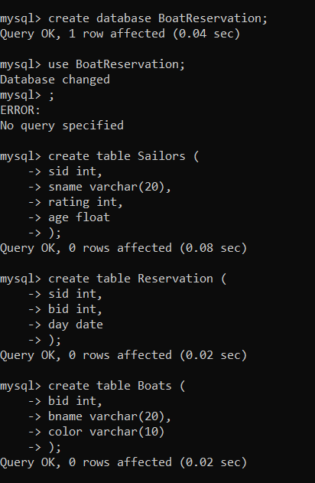

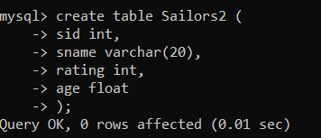

INSERT VALUES (Based on p.5):

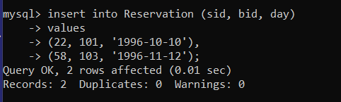

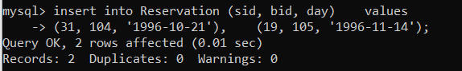

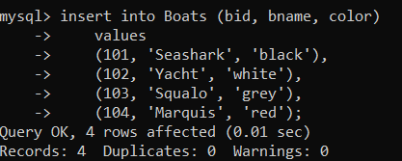

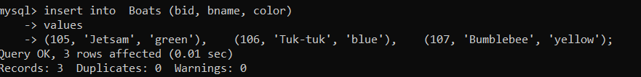

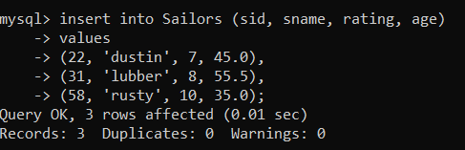

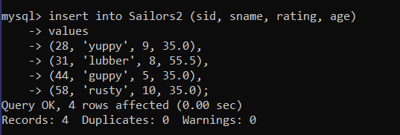

For the following queries:

1)Find names of sailors who’ve reserved boat #103 ‘

**{< N, Bid > | <I, N, T, A> ∈ Sailors (∃ <I, Bid, D> ∈ Reservation ^ Bid = 103) }**

2)Find names of sailors who’ve reserved a red boat

**{< N, C > | <I, N, T, A> ∈ Sailors (∃ <I, Bid, D> ∈ Reservation (∃ <Bid, B, C> ∈ Boats ^ C = ‘Red’))}**

3)Find names of sailors who’ve reserved a red or a green boat

**{< N, C > | <I, N, T, A> ∈ Sailors (∃ <I, Bid, D> ∈ Reservation (∃ <Bid, B, C> ∈ Boats ^ C = ‘Red’ *U* C = ‘green’) )}**

4)Find names of sailors who’ve reserved a red and a green boat

**{< N, C > | <I, N, T, A> ∈ Sailors (∃ <I, Bid, D> ∈ Reservation (∃ <Bid, B, C> ∈ Boats ^ C = ‘Red’ ))} ^ (∃ <I, Bid, D> ∈ Reservation (∃ <Bid, B, C> ∈ Boats ^ C = ‘Green’ ))}**

5)Find the names of sailors who’ve reserved all boats

**{< N, B, Bid > | <I, N, T, A>∈ Sailors (∃<I, Bid, D>∈ Reservation (∃<Bid, B, C>∈ Boats ^ IReservation = Isailors ^ BidReservation = Bidsailors ))}**

OR

**R1:**

**R2:**

**R3: R2 / R1**

NOTES FOR MYSELF:

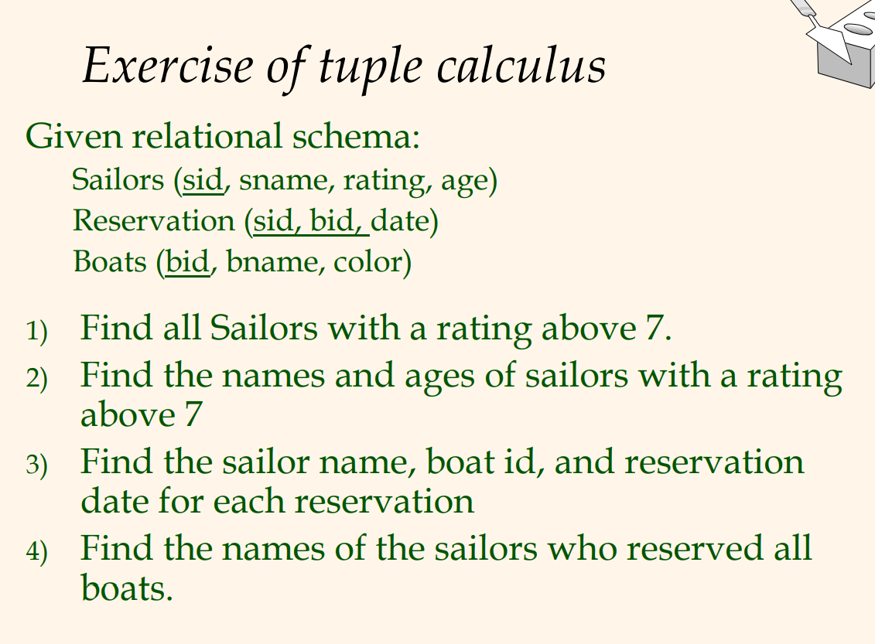

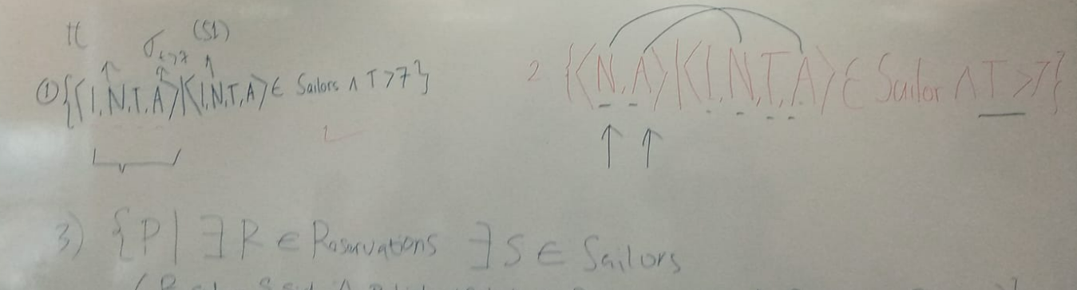

I = ID, N = Name, T = Rating, A = Age

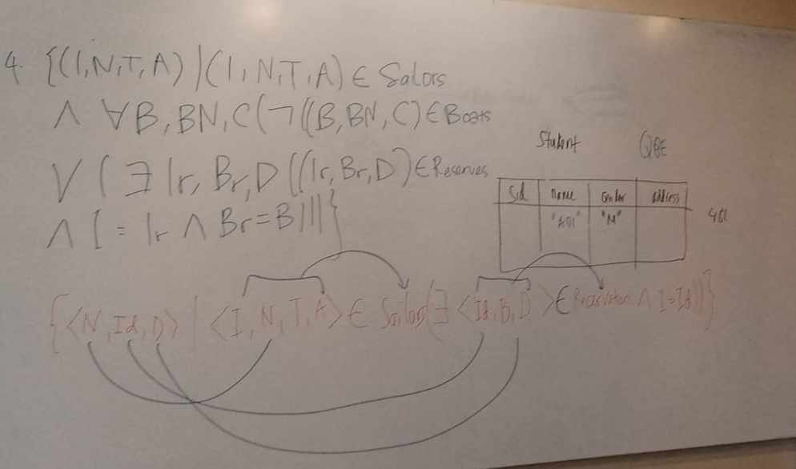

Red is correct answer for question 3

D = Date